Interested in becoming a teacher or learn more about behind the scenes of public education?? Join us this year in Future Teachers of America.
Future Teachers of America (FTA) will be sponsored by Mrs. Krystle Smith and Mrs. Sheena Scott.
Meetings will be from 3:00-4:30 on the following dates.
September 13  October 4  November 8  December 13 | January 17  February 7  March 14  April 11  May TBA (Field Trip)

(Please make arrangments to pick up your child on time)

Club Dues
Club dues cover all meetings during the school year. There is no option to register for individual meetings.
Fee Amount: $15.00
Dues include all materials for most activities. If specialized materials or transportation are required for a specific activity -- this is rare but possible, depending on the activities that club members choose -- there may be an additional charge for that specific activity. If an additional charge is necessary for a specific activity, club members and parents will receive advance notification.
Rules
- Students will be required to attend every meeting. If a situation occurs where the student is unable to attend a meeting, approval for absence will need to be given by club sponsors. Missing two or more meetings will result in a loss of membership.

- Maintain a “C” average (probation period will be given)

- End of the year field trip – students who receive two detentions or an office referral will not be permitted to attend the end of the year trip.
Students are required to follow club rules to participate. Membership will be revoked if rules are not met.
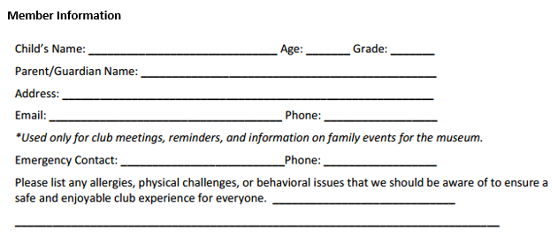
Guardian Consent
I give my consent for my child to participate in the MMS FTA Club.
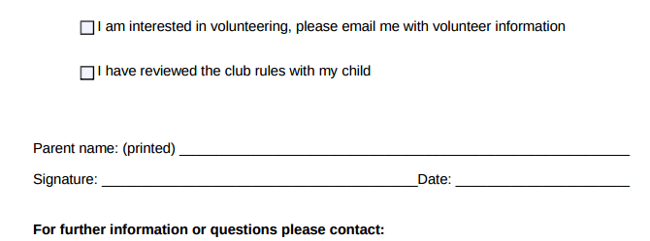
Sheena Scott: Sheena.Scott@wcsk12tn.net
Krystle Smith: Krystle.Smith@wcsk12tn.net

